Obtaining rad_calc in the proper unit: MJ/m2

**var** rad_calc = -1;

**var** rad_calc_display = 'NA';

**var** rad_calc_MJm2 = -1;

**var** rad_calc_Jcm2 = -1;

**if** (rad[row] == '<b><span style="color:red">NA</span></b>'

|| rad[row] == -1

|| **typeof** rad[row] == 'undefined')

{

rad[row] = 'NA';

**var** inv = 1.00011 - (0.03258 * csd) - (0.00755 * snd)

+ (0.00064 * cs2d) + (0.00034 * sn2d);

rad_calc = (0.16 + (0.62 * (((sun[row]) / hrday)))) * c2 * inv * ((csl * csdecl * snhass) + (snl * sndecl * hass)); // rad_cal is in J/m2

**rad_calc_MJm2** = rad_calc / 1000000; // --> Expresses RAD as MJ/m2(04/12/2018 Tony Scott)

rad_calc_Jcm2 = rad_calc / 10000; //rad_calc = rad_calc / 10000; // e-RA units for RAD are J/cm2

// we therefore have to divide by 10000 to give J/cm2(04/12/2018 Tony Scott)

rad_flag_s = '<b><span style="color:red">';

rad_flag_e = '</span></b>'; // we toggle the flags that the calculated values are used

} **else**

{

**if** (rad[1] === "J/cm2") {

rad_calc_Jcm2 = Number(rad[row]);

**rad_calc_MJm2** = rad_calc_Jcm2/100;

}

**if**(rad[1] === "MJ/m2")

{

**rad_calc_MJm2** = Number(rad[row]);

rad_calc_Jcm2 = rad_calc_MJm2 * 100;

}

}

Using Rad_calc

**var** hj_g = d0g * (1000000 * **rad_calc_MJm2**) - fnt2;

**var** evapg = (hj_g * ev1 + (0.66 * ea_grass)) / (delta + 0.66);

**var** hmm = (hj_g * ev1) / 0.66;

**var** hj_w = d0w * (1000000 * **rad_calc_MJm2**) - fnt2;

**var** evapw = ((hj_w * ev1) + (0.66 * ea_water)) / (delta + 0.66);

<.. displaying values .. >

**if** (isNaN(rad_calc)) {

**var** display_rad_calc = '<b><span style="color:red">NA</span></b>';

} **else** {

**if** (rad[1] === "J/cm2") {

display_rad_calc = rad_calc_Jcm2; }

**if** (rad[1] === "MJ/m2")

{

display_rad_calc = rad_calc_MJm2;

}

}

We display;

Rad_flag_s + display_rad_calc + rad_flag_e

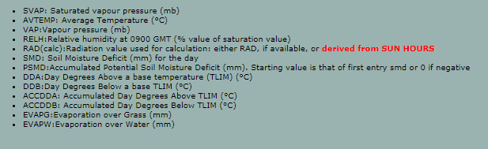

For Broomet, extract of year 1996

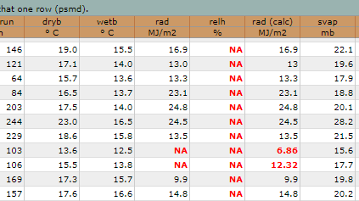

For Rothmet: extract of year 1975 (before flags added)

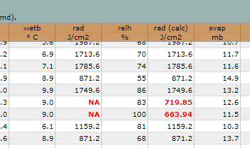

For Wobmet: extract of year 2006

